Implementing Time-Critical Functionalities with a Distributed Adaptive Container Architecture

Vlado Stankovski, Jernej Trnkoczy, Salman Taherizadeh and Matej Cigale
University of Ljubljana, Faculty of Civil and Geodetic Engineering
Jamova cesta 2
SI-1000 Ljubljana, Slovenia
Tel. +386 41 200 565
Vlado.Stankovski@fgg.uni-lj.si

ABSTRACT
Software developers increasingly need to include time-critical functionalities in their Web applications. Examples of these can be Internet-of-Things (IoT), gaming systems, instant messaging, video conferencing, and similar. Ensuring the Quality of Service (QoS) for such applications has been a challenging issue mostly due to runtime variations in the network quality between the clients and the service running in the Cloud. In this paper, we propose an adaptive multi-instance container-based architecture called Autonomous Self-Adaptation Platform (ASAP) that applies an edge computing concept with technologies, such as Docker and Kubernetes to facilitate the desired QoS for every single usage event of the time-critical functionality. We use a “File Upload” use case as an example to explore time-critical functionality. Each time a client needs to use the File Upload functionality, a specific setup, physical host selection and resources allocation is made in order to provide the desired QoS to that functionality.
Categories and Subject Descriptors
• Software and its engineering ~ Software development methods • Software and its engineering
Keywords
Time-critical, container, multi-instance, software engineering.

INTRODUCTION
Today, many Web applications need to incorporate time-critical functionalities. Time-critical functionalities are particularly relevant for applications involving the IoT, media streaming and gaming, instant messaging etc. The variety of users for such applications may be diverse, thus, all of them may pose different requirements to the applications, while others may not have such requirements.
The developers of such applications need to have in mind the time-critical aspects that have to be included in their applications and some Cloud-supported mechanisms where various vertical and horizontal scaling may be possible[1]. Emerging container-related technologies could be used to support such time-critical functionalities by allowing for the development of more flexible and extensible execution environments, thus always providing the required Quality of Service (QoS) to the applications [2].
Thus, the goal of this paper is to address the needs of specific type of Web applications designed to serve relatively short lasting events (from few minutes to a couple of hours), which have very specific QoS requirements. In the basic use case, each time an event takes place, the usage context should be captured, a hosting infrastructure must be selected, a set of containers must be setup, deployed and started with specific infrastructure requirements. The hosting infrastructure is selected from a set of federated physical hosts or from private or public Cloud offerings in which best QoS can be obtained based on an application administrator selected strategy (e.g. fastest speed, zero packet loss and similar).

MOTIVATING USE CASE
Let us consider a very simple Web application: the user selects a file on her local device, and presses a button to upload it. We call this use case “File Upload” as it is designed to provide such functionality to the user. Typical File Upload time-critical events can be classified according to the sizes of files to be uploaded, e.g. Small, Medium and Large files. The functionality can be implemented by as an HTTP server. The container can then be deployed in a public Cloud, while the users who wish to upload their files may come from various countries World-wide. Let us note that the QoS for this functionality may be significantly different for users coming from different geographic regions due to best effort Internet connections providing for various degrees of bandwidth between the clients and the File Upload server.
The basic idea of this scenario is that when the software engineer has to take care about a time-critical aspect in the Web application, it is possible to rely on an independent container that would provide the required QoS for that particular functionality (e.g. File Upload). For this to be made possible, it is necessary that the containerized application is deployable in different geographic locations and the required resources (memory, CPU time etc.) to the running containers can be allocated.
In our scenario the service is created, served and destroyed for every File Upload request. An adequate selection of the geographical location, physical host and allocated resources is supposed to improve the QoS of the application, reduce its operational cost and satisfy any other operational strategies defined by the application developer and/or administrator.
This scenario requires a multi-instance architecture so that elasticity to a varying number of usage events is automatically achieved [3]. There are no permanent servers/resources, since they are rather set-up dynamically according to the number and location of clients (users, cameras, sensors, smart phones). The proposed scenario follows the edge computing trend as it intends to provide the computation/storage near the data source [4]. Our software engineering approach is made possible by the invention of container-based virtualization, which offers easy and fast deployment (usually within seconds) [5].
The File Upload scenario although very simple, represents functionality, in which QoS may depend on many factors, for instance networking between the client and the server and the allocated resources at the host machine [6]. The role of the ASAP is to determine the infrastructure where the “temporary file upload server” will be installed to serve a particular File Upload event.
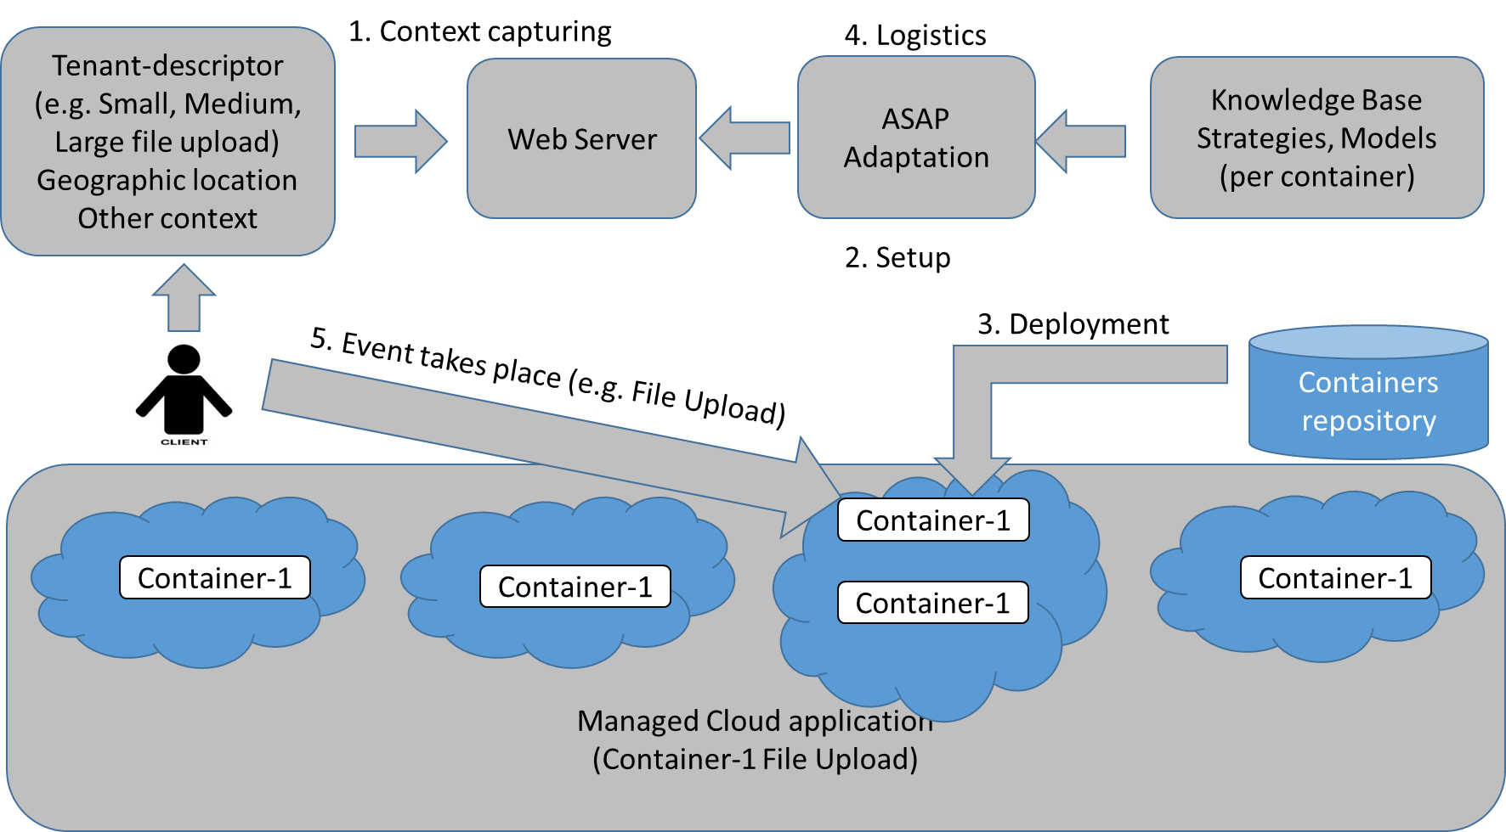
Figure 1. Launching a new container instance for a time-critical functionality.

The use case scenario is illustrated in Figure 1. The File Upload Web application first needs to identify the geographic location of the user, and the file size to be uploaded as these things may influence the selection of the host machine in which the File Upload container will be deployed (1. Context capturing). Then the Web server can contact an adaptation module to decide on which of the available host machines it is best to run the “temporary HTTP File Upload server”, which is packed into a container. Next stages of this scenario are deployment based on a QoS model for the given time-critical functionality (aiming to find out the appropriate amount of memory and other resources). In the last part of this process, when the “temporary File Upload HTTP server” has been deployed and is running, the actual file upload may take place (5. Event takes place). Although there are series of steps prior to the actual file upload which may cause small delay, the overall performance of the File Upload is supposed to be significantly improved by following this scenario.

ARCHITECTURE
The proposed architecture, which has been named as Autonomous Self Adaptation Platform (ASAP), is designed to enable highly adaptability, thus making it possible to select the optimal infrastructure and containers setup for the given time-critical functionality and usage context to achieve the required QoS.

Quality of Service Considerations
A time-critical functionality may depend on various resources such as network bandwidth, CPU frequency, memory allocation etc. The allocation of these resources may be of different importance for different applications. For the File Upload use case the network bandwidth is expected to be the limiting factor. But other factors, such as disk write speed, or memory can have an impact. The network bandwidth problem is also extremely interesting, as it is one of the characteristics of the system that usually cannot be adapted outright but needs to be mitigated by moving the execution of the application to a different location.

Adaptive Platform Architecture
The key components of the ASAP architecture can be seen on Figure 2. The first is the Monitoring System that captures the information about the infrastructure, network, container and application. The container used for our application must contain all the necessary handles so that monitoring can be achieved.
The crucial metric that has to be monitored is the QoS metric that represents the usability of the application. The monitoring system has three parts, the Monitoring Probes that interact with the application, the Monitoring Agent that aggregates the data from the probes and is responsible for managing them, and the Monitoring Server that stores the monitoring data to the Time Series Database (TSDB).
The Performance Diagnoser component generates an application model that predicts the QoS of an application. The model is generated in several stages from metrics collected by running the application on several different infrastructures before the application is deployed. In the first stage the metrics that have no effect on the QoS are removed until only a small subset of metrics is chosen that has a relatively good chance of estimating the desired QoS. This model is then stored into the knowledge base and is available for other components.
The Decision Maker is responsible for determining the type and parameters of adaptation needed to reach the desired QoE. These parameters can be the infrastructure where the application will run, the amount of memory and CPU reserved for it etc.
It is the job of the Setup & Control component to actually deploy the container to the desired location, or change its characteristics. This is done so that the finished system is flexible.

Workflow among the ASAP components
In the following we describe the process of using the ASAP components. Before the time-critical functionality can be deployed it has to be analyzed (see Figure 3). At this stage the application is run on various infrastructures with varying degree of success. During these trial runs the metrics are collected so that they can be used as input into the Machine Learning algorithm that creates the application model.
The collected metrics are used in the next stage to create a model of the application. If more than one QoS metric is required for the application, each requires the creation of a separate model.
When the time comes to deploy the Startup Optimizer is called to find the optimal configuration for the application. It uses the created application model and the information on available infrastructure to select the “optimal” configuration that satisfies the requirements. Then the application is deployed and is monitored for any possible faults in the system (Figure 4). If in the course of the application runtime some QoS parameters goes below thresholds, then the system needs to change in which case the runtime adaptation is called (e.g. a new container instance is created).

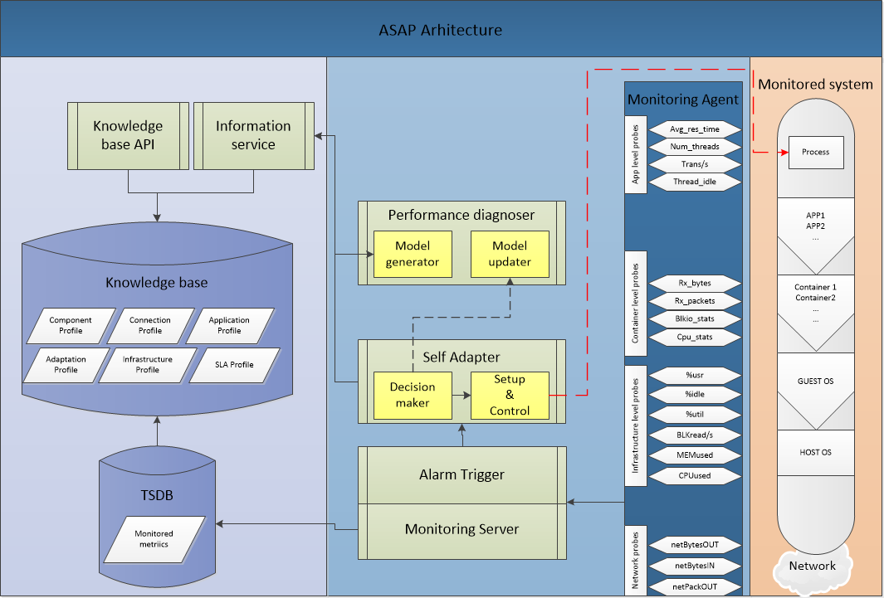
Figure 2. Architecture of the Autonomous Self-Adaptation Platform (ASAP).

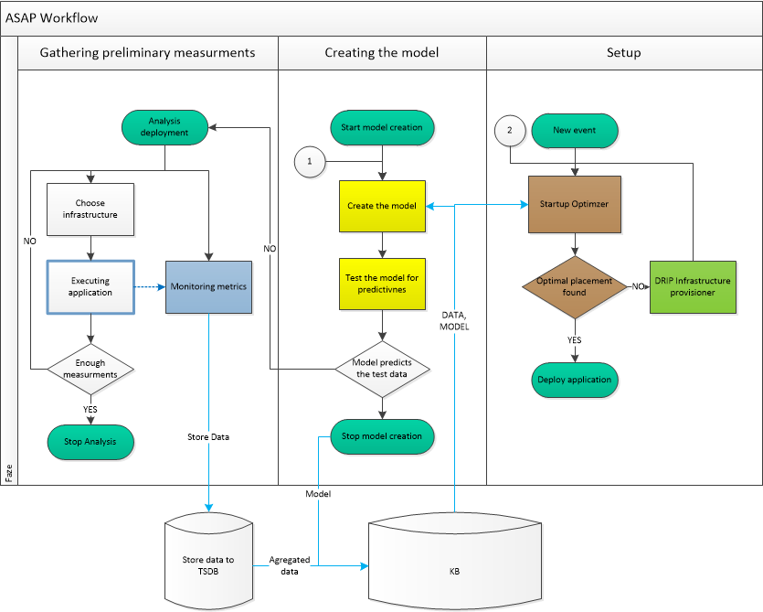
Figure 3. Flow of the ASAP subsystem: Deployment.

USE CASE IMPLEMENTATION

Technological considerations
Container-related technologies that have been considered for our implementation have been CoreOS, Docker and Kubernetes. Following is a brief account of these technologies and their usefulness for the purpose of our work.

Docker and containers
Containerization is the process of distributing and deploying applications in a portable and predictable way. These are not new ideas, with some operating systems leveraging containerization technologies for over a decade [7].
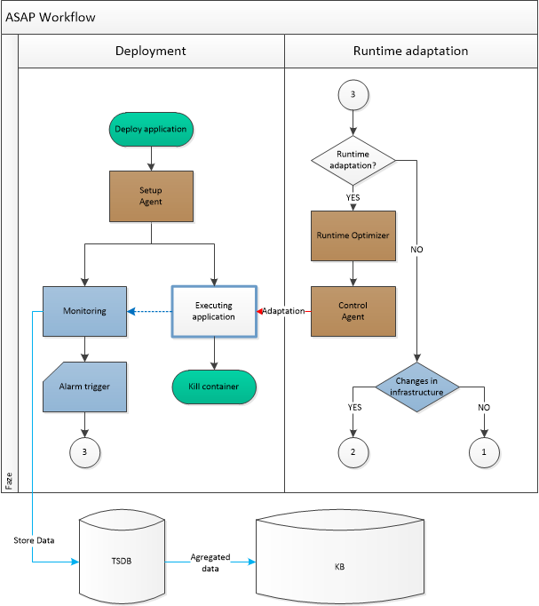
Figure 4. Flow of the ASAP subsystem: Runtime.

For example, LXC, was added to the Linux kernel in 2008. It combined the use of kernel cgroups (allows for isolating and tracking resource utilization) and namespaces (allows groups to be separated) to implement lightweight process isolation.
Containers come with many attractive benefits for both developers and system administrators. These include: abstraction of the host system away from the containerized application, easy scalability, simple dependency management and application versioning, lightweight execution environments etc. [8]. Comparing to VM virtualization, containers provide a lighter execution environment, since they are isolated at the process level, sharing the host's kernel. This means that the container itself does not include a complete operating system, leading to very quick startup times and smaller transfer times of container images.
Among several containerization technologies available today, Docker is the most common containerization software in use [9]. While not introducing many new ideas, Docker made containerization technologies accessible by simplifying the process and standardizing on an interface. It was developed to simplify and standardize deployment in various environments. By packaging up the application with its configuration and dependencies and shipping as a container image, the application will always work as designed locally, on another machine, in test or production. Moreover, Docker containers spin up and down in seconds making it easy to scale an application service at any time to satisfy peak customer demand, then just as easily spin down those containers to only use the resources you need when you need it. These properties make Docker an ideal choice for our use case which requires highly dynamic service startup and shutdown.
Docker images are read-only templates from which Docker containers are launched [10]. An image can be basic, with nothing but the operating-system fundamentals or it can consist of a sophisticated pre-built application stack ready for launch.

Kubernetes
When applications are scaled out across multiple host systems, the ability to manage each host system and abstract away the complexity of the underlying platform becomes necessary. Container orchestration is a broad term that generally refers to cluster management and container scheduling. Kubernetes is one of the systems for managing containerized applications across multiple hosts, providing basic mechanisms for deployment, maintenance, and scaling of applications. It provides advanced container orchestration capabilities, such as: co-locating helper processes, facilitating composite applications, mounting storage systems, distributing secrets, application health checking, replicating application instances, horizontal auto-scaling, naming and discovery, load balancing, rolling updates, resource monitoring, log access and ingestion, support for introspection and debugging, and identity and authorization. Kubernetes establishes robust declarative primitives for maintaining the desired state requested by the user. Self-healing mechanisms, such as auto-restarting, and replicating containers are supported.

Using the Implemented Prototype
The File Upload follows the steps identified in the Figure 5: (1) A client wants to upload a file to the cloud. It sends an HTTP request to the web server. (2) The web server extracts the IP of the client, which is then forwarded to the Decision Maker. (3) The Decision/Adaptation module sends the decision back to the web server. (4) The web server now initiates the creation of the Kubernetes service and pod on the chosen machine. (5) Due to asynchronous nature of Kubernetes API the web server has to register a listener which is notified when the service and the pod are created. (6) The web server can now prepare appropriate HTML, containing the web form for file upload. The web form contains the address of the created Kubernetes “pod” which is exposed through the Kubernetes service. The resulting HTML is sent to the client. (7) The client can now initiate the file upload. (8) When the file upload finishes the Java Servlet that is handling the file reception initiates the request to the web server responsible for communication with the Kubernetes API. The request initiates the “pod” and associated “service” destruction. (9) The Web server sends the request for “pod” and “service” teardown to the Kubernetes API. This call is asynchronous. (10) This is why the response to the Container is immediate. (11) Once the container received all parts of the file it can send response back to the client.
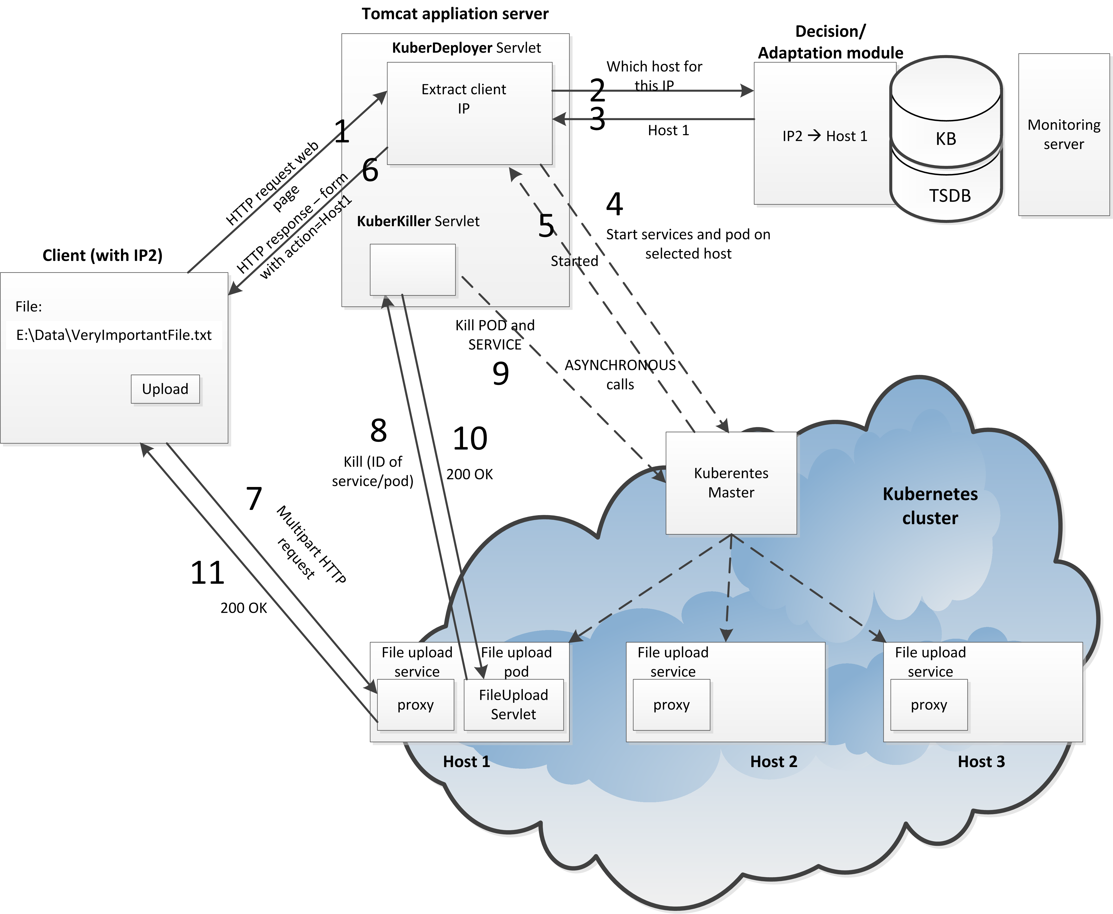
Figure 5: Detailed flow of the File Upload application.

QOS METRICS MEASUREMENTS
Considering the File Upload use case, Table 1 shows the application-specific metrics monitored by the application-level Monitoring Probe. In this table, the application’s type is defined as a Java-based server since we have thoroughly developed and implemented this application via Java language.

Table 1. Application-level metrics in the File Upload use case.
Probe | Metric | Description
Java-based Server  (Application-level) | cpuPercentage | Percentage of current CPU usage by the application running in the container
Java-based Server  (Application-level) | memPercentage | Percentage of current memory usage by the application running in the container

Figure 6 and Figure 7 are diagrams of cpuPercentage and memPercentage monitoring just for one running container during a period of time with the changing workload.
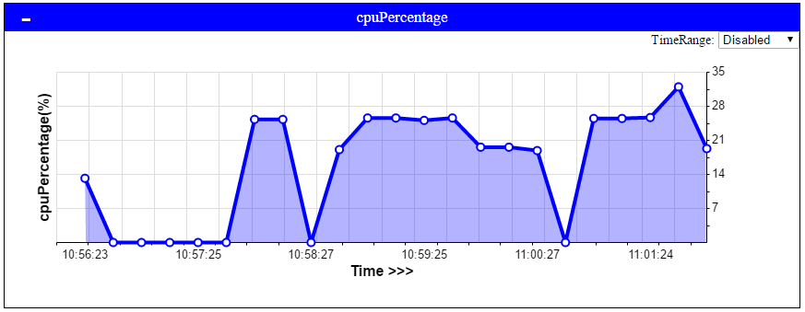
Figure 6. Application-level cpuPercentage.
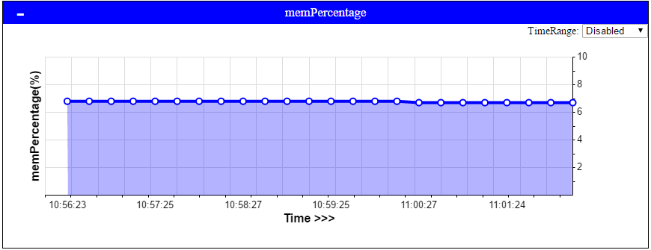
Figure 7. Application-level memPercentage.

It is clear that the File Upload application is not a CPU and memory consuming process. Because on the maximum workload, the application consumes just 32 percent of the whole CPU power and it has a steady utilization of memory as just 7 percent of the whole memory space.
Table 2 shows the infrastructure-level metrics monitored by the associated Monitoring Probe to measure disk-related parameters.
Table 2. Infrastructure-level metrics in the File Upload use case.
Probe | Metric | Description
Disk  (Infrastructure-level) | readkbps | KB read to disk per second
Disk  (Infrastructure-level) | writekbps | KB written to disk per second

Figure 8 is the diagram of writekbps monitoring for the mentioned running container during a period of time with the changing workload.
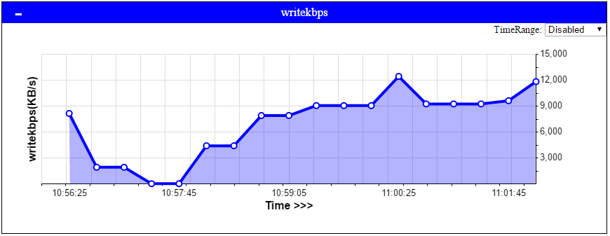
Figure 8. Infrastructure-level writekbps.
It can be understood that writekbps metric is directly related to the current workload to deposit the files on the disk.
Table 3 shows the container-level metrics monitored by the implemented Monitoring Probe to measure network parameters.
Table 3. Container-level metrics in the File Upload use case.
Probe | Metric | Description
Network  (Container-level) | netPacketsIn | Packets in per second
Network  (Container-level) | netPacketsOut | Packets out per second
Network  (Container-level) | netBytesIn | Number of bytes in per second
Network  (Container-level) | netBytesOut | Number of bytes out per second

Figure 9 is the diagram of netBytesIn monitoring for the previous running container during the same period.
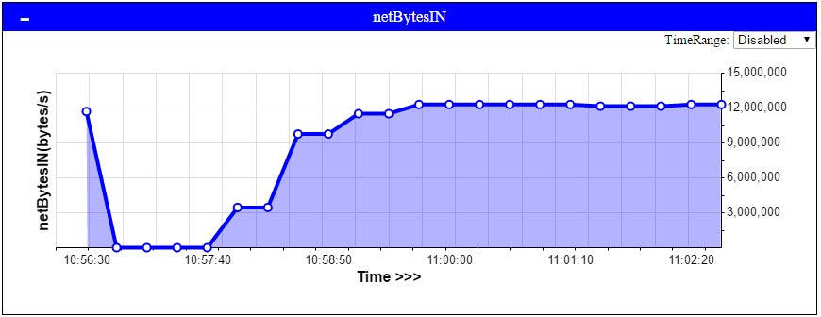
Figure 9. Container-level netBytesIn.
Figure 9 indicates that there is a limitation for the container's incoming traffic which is ~12,000,000 bytes.

CONCLUSIONS
An important goal of our work was to investigate a software engineering approach for implementing time-critical functionalities. The result of our work is a new container-based Autonomous Self-Adaptation Platform (ASAP), which may be used to achieve the desired QoS. The presented architecture of the ASAP system is event driven and is designed to allow for intelligent selection of physical hosts, allocation of appropriate resources to containers, and similar adaptations in order to achieve the required QoS operation. The implemented prototype also fits into the concept of edge computing.

ACKNOWLEDGMENTS
This project has received funding from the European Union’s Horizon 2020 Research and Innovation Programme under grant agreements no. 643963 (SWITCH project: Software Workbench for Interactive, Time Critical and Highly self-adaptive cloud applications) and no. 644179 (ENTICE project: dEcentralized repositories for traNsparent and efficienT vIrtual maChine opErations).

REFERENCES
- Zhao, Z., Martin, P., Wang, J., Taal, A., Jones, A., Taylor, I., Stankovski, V., Vega, I.G., Suciu, G., Ulisses, A. and de Laat, C. 2015. Developing and operating time critical applications in clouds: the state of the art and the SWITCH approach. In Proceedings of the 1st International Conference on Cloud Forward: From Distributed to Complete Computing, 68, pp.17-28.
- Evans, K., Jones, A., Preece, A., Quevedo, F., Rogers, D., Spasić, I., Taylor, I., Stankovski, V., Taherizadeh, S., Trnkoczy, J. and Suciu, G. 2015. November. Dynamically reconfigurable workflows for time-critical applications. In Proceedings of the 10th Workshop on Workflows in Support of Large-Scale Science (p. 7). ACM.
- Chard, R., Chard, K., Bubendorfer, K., Lacinski, L., Madduri, R. and Foster, I. 2015. June. Cost-aware elastic cloud provisioning for scientific workloads. In 2015 IEEE 8th International Conference on Cloud Computing, IEEE, 971-974.
- Shi, W., Cao, J., Zhang, Q., Li, Y. and Xu, L., Edge Computing: Vision and Challenges. Technical Report MIST-TR-2015-008. Wayne State University, Detroit, 10 pages.
- Seo, K. T., Hwang, H. S., Moon, I. Y., Kwon, O. Y. and Kim, B. J. 2014. Performance comparison analysis of Linux container and virtual machine for building cloud. Advanced Science and Technology Letters, 66, 105-111.
- Taherizadeh, S., Taylor, I., Jones, A., Zhao, Z., and Stankovski, V. (2016). “A network edge monitoring approach for real-time data streaming applications”. In Proceedings of the 13th International Conference on Economics of Grids, Clouds, Systems and Services (GECON 2016), ACM, Athens, Greece.
- Morabito, R. 2016. A Performance Evaluation of Container Technologies on Internet of Things Devices. arXiv preprint. arXiv:1603.02955.
- Paraiso, F., Stephanie, C., Yahya, A. D. and Merle, P. 2016. Model-Driven Management of Docker Containers. In 9th IEEE International Conference on Cloud Computing (CLOUD).
- Merkel, D. 2014. Docker: lightweight linux containers for consistent development and deployment. Linux Journal. 2014(239), p.2.
- Boettiger, C. 2015. An introduction to Docker for reproducible research. ACM SIGOPS Operating Systems Review. 49(1), 71-79.

