Pridobivanje podatkov v Excel-u

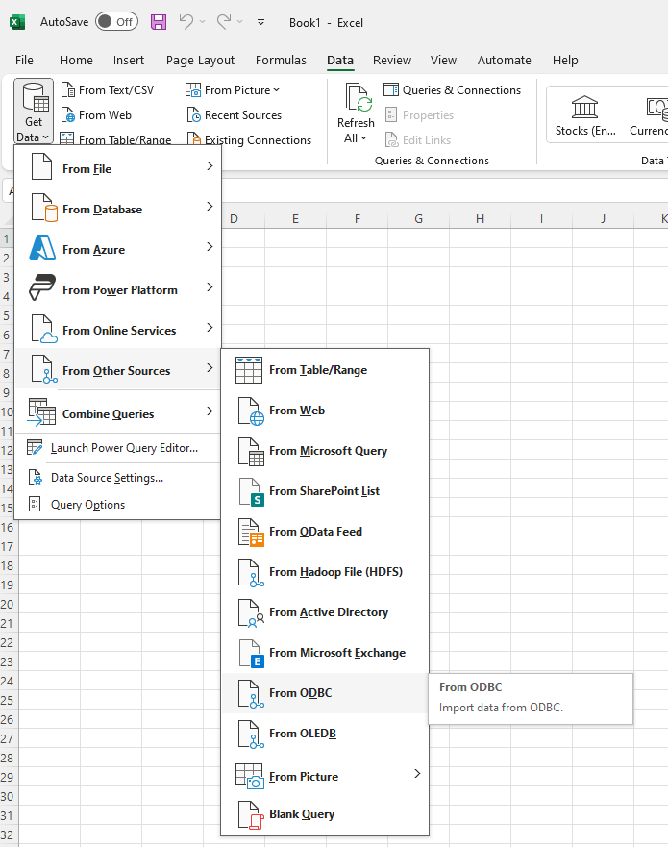

Tako dobimo rezultat poizvedbe v tabelo

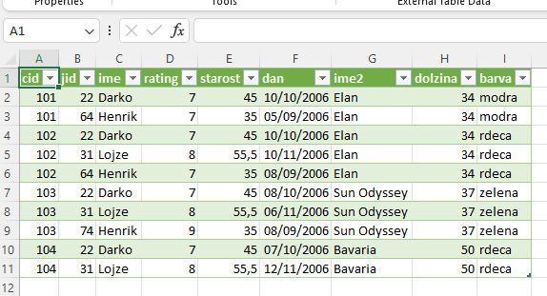

Nato vstavimo vrtilno tabelo:

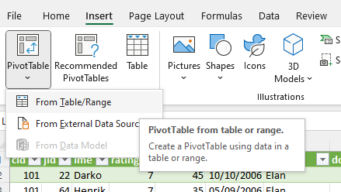

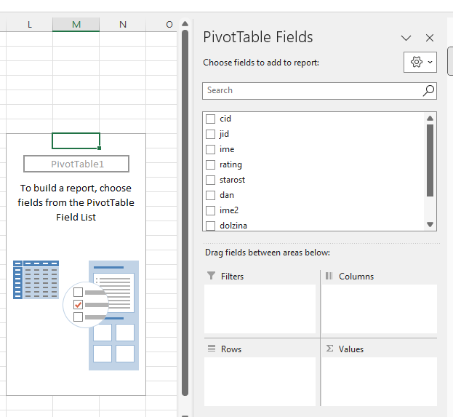

In potem postavimo ustrezna polja